Gus Fontenot
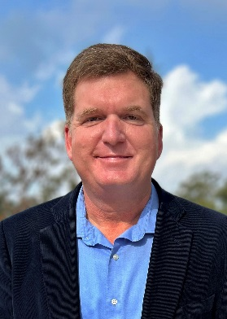
Gus has been with The Alliance since 2017, overseeing the Louisiana Certified Sites and the Louisiana Competes programs at the Regional EDO level. He works to find new industrial sites across Southwest Louisiana, participates in Business Retention efforts, helps facilitate site showings, and responds to RFI’s. He currently serves on the Communications Committee for the Southern Economic Development Council and is the Chamber Liaison to the Environmental Affairs Committee for the Chamber Southwest, a five-star accredited chamber.
Native of Cameron Parish.
Graduate of South Cameron High School and Louisiana State University with a Bachelor of Arts degree in Mass Communication.
Current job title: Director of Special Projects and Site Development for the Southwest Louisiana Economic Development Alliance
Previous job titles: Communications Specialist, Assistant Planner, Business Development, Public Relations, Customer Service, and many others
Previous employers: CB&I (Chicago Bridge & Iron), Lafayette General Health, Cameron Parish Police Jury, Phillips & Jordan, Inc., Holiday Inn Hotels, Sabine Pools & Spa, Thompson South Louisiana Publishing, The Times of Southwest Louisiana, Gannet News, Jennings Daily News.

